**Image Printing Program Based on Halftoning**

Cody A. Ray

This project proposes to write an image printing program based on halftoning.

The following figure shows ten shades of gray approximated by dot patterns. Each gray level is represented by a 3 x 3 pattern of black and white dots. A 3 x 3 area full of black dots is the approximation to gray-level black, or 0. Similarly, a 3 x 3 area of white dots represents gray level 9, or white. The other dot patterns are approximations to gray levels in between these two extremes. A gray-level printing scheme based on dots patterns such as these is called "halftoning." Note that each pixel in an input image will correspond to 3 x 3 pixels on the printed image, so spatial resolution will be reduced to 33% of the original in both the vertical and horizontal direction.

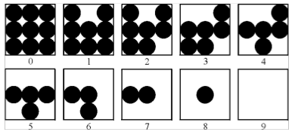

We will implement this system in MATLAB. The above image was found on the website corresponding to the class textbook. Other images used will be from the book or pre-installed with MATLAB.

The final deliverables for this project are a halftoning computer program for printing gray-scale images based on the dot patterns just discussed, a series of tests or experiments based upon this implementation, and a report summarizing my findings.